Statistical Learning

Homework #4

Duncan Wilson  
February 24, 2015

Problem 2.

Perform Fisher Discriminant Analysis on three subsets of the zip-code data.

The dimensionality is reduced by projecting from $R^{256}$ down to $R^{1}$ by the following process:

$\overset{⃑}{a}= {{(Σ }_{1}Σ_{2})}^{-1} X^{T}y$ with $X^{T}y=N({\overset{⃑}{μ}}_{1}-{\overset{⃑}{μ}}_{2})$

Here is the histogram from comparing the 2’s against the 3’s:

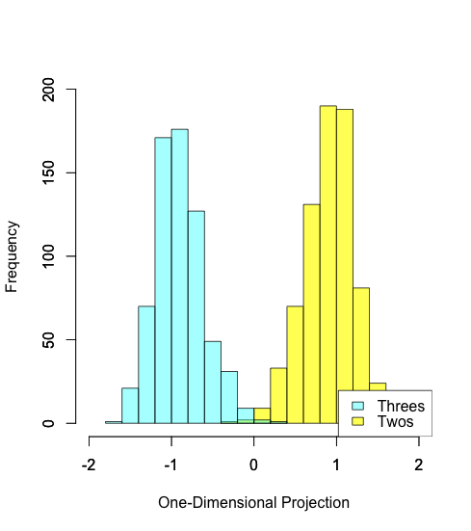

After fitting a Gaussian to each of these distributions, the program produced classification on the dimension-reduced test set with 95.88% percent accuracy.

Here is the histogram from comparing the 4’s against the 5’s:

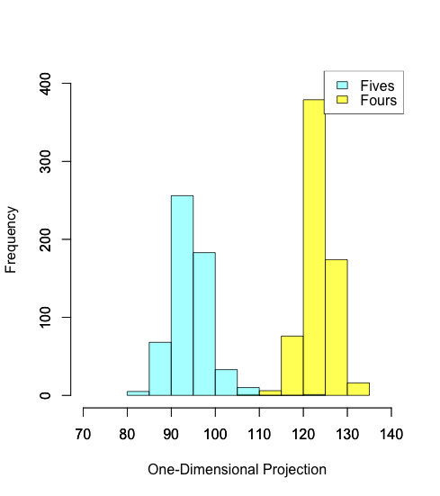

After fitting a Gaussian to each of these distributions, the program produced classification on the dimension-reduced test set with 98.05% percent accuracy.

Here is the histogram from comparing the 4’s against the 5’s:

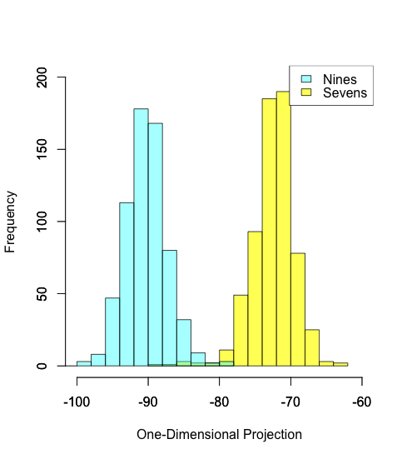

After fitting a Gaussian to each of these distributions, the program produced classification on the dimension-reduced test set with 94.75% percent accuracy.